

**Physical geography Chapter 4: Rocks**

# Mineral

A mineral is a naturally occurring substance which has certain physical properties and a definite chemical composition

# Rock

A rock is an aggregate of mineral particles forming part of earth crust. Rocks differ in shape, size, color and texture.

# Types of rocks

The three types of rocks are Igneous Rock, Sedimentary Rock, and Metamorphic Rock according to the mode of formation

# Igneous/formed rocks

Igneous rocks are fine formed rocks due to vulcanicity**.** They are formed when molten magma cools and becomes a solid. They can form either on the surface (extrusive igneous rocks), or deep in the crust (intrusive or plutonic igneous rocks).

# The process responsible for the formation of igneous rocks in East Africa

Igneous rocks are fire formed rocks. The main process of formation is vulcanicity. This is the process by which molten rock (magma/lava) cools down, crystallizes and solidifies either within the earth's crust to form intrusive rocks or onto the surface of the earth to form extrusive rocks.

Vulcanicity originates from the interior of the earth due to radio activity, geochemical reactions and connectivity within the mantle - a lot of heat is generated that melts the rocks in the mantle creating convective currents. These currents exert pressure on crustal rocks creating lines of weakness/ fissures through which molten rocks is either intruded or extruded.

Igneous rocks are categorized according to rate of cooling/depth and chemical composition.

Igneous rocks according to rate of cooling and depth they include;

• **Plutonic rocks/ Abyssal rocks**:

* These are formed from cooling and solidification of magma at great depth hence they are deep seated rocks.
* The intruded magma cools and solidifies extremely due to lack of contact with air leading to formation of rocks with large crystals such as granite, gabbro, diorite, synite etc.
* These rocks are found in features such as exposed batholith at Mubende, Singo etc.

• **Hypabyssal/intermediate rocks:**

* These are formed from magma that cools and solidifies near the surface of the earth/shallow depth. The rate of cooling is moderate leading to formation of medium sized crystals e.g. Quartz, dolerite, porphyry, etc.
* They are found in features such as dykes in Turkana land etc.

• **Volcanic rocks/extrusive rocks:**

* are formed from fast cooling of lava extruded onto the surface of the earth due to exposure to air leading to the formation of rocks that have very small crystal e.g. obsidian, basalt, andesite, pumice etc.
* Some of the volcanic rocks are spongy in nature such as pumice due to enclosure of gases at cooling time.
* Some rocks are glassy in appearance such as obsidian.
* Some rocks are dark coloured such as Basalt.
* Volcanic rocks are mainly found in features such as volcanic mountain e.g. Elgon, lava plateaus such as Yatta etc.

Igneous rocks according to chemical composition:

Magma/ lava vary in chemical composition and so has an effect on its viscosity/thickness which in turn influences the rate of cooling and the process of crystallization. In this category the rocks include;

* **Acidic/felsic rocks:** these have a high content of silica (65%) and 35% or less basic oxides. They are light coloured, have low density e.g. granite, diorite, Rhyolite, Andesite etc.
* **Intermediate rocks** have moderate silica content between 55- 65% and 45-35% basic oxides.

They are a mixture of mineral structure of acidic and basic e.g. poryphyites.

* **Basic rocks** contain much mica and olivine. They are rich in iron and magnesium. They are dark coloured, dense or heavy, have low silica content between 45-55% and 55- 45% basic oxide

**Igneous rocks are generally characterized by the following:**

* They are crystalline in structure - They do not contain fossils.
* Some are spongy in nature such as Pumice.
* Some are dark coloured such as Basalt
* They do not occur in layers/strata
* Some are acidic, basic and intermediate in chemical composition etc.
* They are concentrated in areas of crustal instability and vulcanicity such as rift valley

Examples of igneous rocks include; Granite, Quam, Gabbro, Pumice, Basalt, Obsidian, Dolerite, diorite etc.

**Importance of igneous rocks**

**Positive importance of igneous rocks**

* Polished granite is commonly used to make countertops.
* Basalt is a main rock in the construction industry. It is an ingredient in concrete.
* Pumice is also an ingredient in lightweight construction materials.
* Breakdown to form fertile soils
* Contain mineral such as diamond in Tanzania
* Form water falls used for generation of hydroelectricity and tourist attraction
* Influence supply of water in spring wells
* Igneous rocks formed highlands like Mt. Kilimanjaro that support different plant and wildlife

**Negative importance of igneous rocks**

* Igneous rocks such as granite are hard and take long to weather to produce soil that support agriculture e.g. at Turkana land in Kenya.
* Igneous rocks form highlands that shield rain on leeward side such as that of Mt. Elgon and Mt. Kilimanjaro
* Igneous rocks form highlands that limit transport and communication such as in Kabale-Kisoro region in Uganda.
* Igneous rocks form highlands that experience land slide destroying property and lives such as on Mt. Elgon
* Igneous rocks are formed through volcanic eruption that release hot magma and gases that destroy property and life such as Nyamulangira in DR Congo

# Sedimentary rocks

Sedimentary rocks are rocks that are composed of particles of rocks that have been deposited in layers by water, wind or moving ice.

They are characterized by the following;

* They are stratified /occur in layers - They contain fossil.
* They are non-crystalline in nature
* The layers are separated by bedding planes.
* The strata are either, horizontal, gently sloping or steeply dipping.
* They are concentrated around water bodies e.g. Indian Ocean, Lake Victoria and L. Albert

Examples include; Sandstone, mudstone, clay, rock salt; coral, limestone, dolomites, soda ash, gypsum, iron ore, iron stone, etc.

**Importance of sedimentary rocks**

**Positive importance of sedimentary rocks**

* Sand and gravel are used to make concrete n construction industry
* Limestone for marking cement
* Shale is used as a component in cement production
* It is important in the formation of beaches, spits, sand bars and estuaries and provides substrates for aquatic plants and animals.
* It provides nutrients and minerals vital to the health of downstream ecosystems.
* Rock gypsum is used to make plaster.
* Natural gas, oil, coal, uranium, and other energy resources are formed in and come from sedimentary rocks.
* Provide materials for brick making e.g. clay at Kajansi for making tiles

N**egative importance of sedimentary rocks**

* Form immature soils that are unproductive e.g. in Semuliki basin and coastal areas of Mombasa.
* Form vast wastelands due to coarse sedimentary deposits e.g. sand dunes - Sedimentary rocks such as coral reefs are barrier to shipping at Mombasa. - Sedimentary rocks tend to influence flooding due to fine silt and clay materials - They are associated with infertile soils due to leaching.

# Metamorphic rocks

They are formed when igneous rocks or sedimentary rocks are subjected to great heat and high pressure for a very long time

Characteristics of metamorphic rocks

* Crystalline and often have a “squashed” (foliated or banded) texture.
* Rarely have fossils.
* May have alternate bands of light and dark minerals.
* May be composed of only one mineral, e.g., marble & quartzite.
* Very hard
* Usually made of mineral crystals of different sizes.
* Rarely have pores or openings.
* They are the oldest rocks in East Africa

Examples are Slate, schist, gneiss, quartzite and marble.

**Importance of metamorphic rocks**

**Positive importance of metamorphic rocks**

* Metamorphic rocks such as marble are used in construction
* Valuable minerals such as Mica in Northern Uganda, diamond in Mwadui in Tanzania and copper in Kilembe mine occur in metamorphic rocks
* Form strong basements for tunnel and dam construction
* Act as aquifer water source for example Artesian wells in Sudan and Kenya
* Used as grinding stones
* For study purpose

**Negative importance of metamorphic rocks** - Take very long to weather.

* Generally yield poor soils
* They are barrier to transport
* Metamorphic rocks form highlands that experience landslides.

# Influence of igneous rocks on landform development in East Africa

In East Africa Igneous form

1. Extrusive volcanic features such Ash and cinder cones. Composite cones/strato volcanoes, Shield volcanoes, Lava plateaus, Volcanic plug, Volcanic neck, Cumulo dome, Caldera. Hot springs, Geysers and Fumaroles.
2. Intrusive volcanic features; Batholiths, Inselbergs, Dykes, Ridges, Sills, Laccoliths, Uplands.

These were fully discussed in chapter 3 i.e. vulcanicity in East Africa

**Influence of Rock structure on the development of drainage patterns in East Africa.** The aspects of rock such as rock hardness, rock jointing, rock dip, stratification, mineralogical composition, homogeneity, rock heterogeneity had a big influence on the development of different drainage patterns in many ways. These include:

1. **Rectilinear or Trellis drainage pattern**
   * It is a drainage system were tributaries join the main stream at approximately right angle (900).
   * It forms in areas of jointed and faulted rocks or areas of alternate soft and hard rocks demarcated by joints at approximately 900.
   * Erosion of soft rocks guided by the fault lines or joints leaves channels through rivers flow.
   * Examples occur on R. Mayanja- Kato, Wasswa in Kichwamba, R. Aworanga, Pager, Aswa, Tiva and Galana,

-

1. **Parallel drainage pattern**
   * A parallel drainage pattern consists of rivers and streams that run parallel to each other.
   * It is formed in areas of alternate bands of soft and hard rocks lying side by side.
   * Soft rocks are eroded to form the river channels while the hard rocks resist erosion to form a divide which limit chances of adjacent rivers joining each other.
   * Examples include R. Nkusi and R. Hoima flow parallel to each other before joining L. Albert in Uganda and tributaries of River Athi such as R. Nairobi, Thirika, Komu and Ruiru flow parallel to each other in Kenya
2. **Dendritic and radial drainage patterns.**
   * Dendritic drainage pattern is pattern where tributaries join the main stream at angles less than 900.
   * Dendritic and radial drainage patterns are formed in areas of Homogeneous or crystalline igneous rocks
   * Uniformity of the rock structure enables the rivers to erode any region with minimum effort thus creating a variety of tributaries.
   * Example are found on R. Rufigi, Victoria Nile, R. Malagalasi. Ruvuma in Tanzania and River Nyando.
3. Radial drainage pattern
   * Radical pattern is a type of drainage pattern which develops when streams flow in different directions from a central peak or dome like structure.
   * It forms in areas of steeply dipping rock for instance from the tip of volcanic mountains.
   * Examples of radial patterns are found on Mt. Elgon comprising rivers Sironko, Manafa, Siti and Koitobos and on Mt. Rwenzori comprising Rivers Mubuku, Nyamugasani, Lume and Ruanoli.

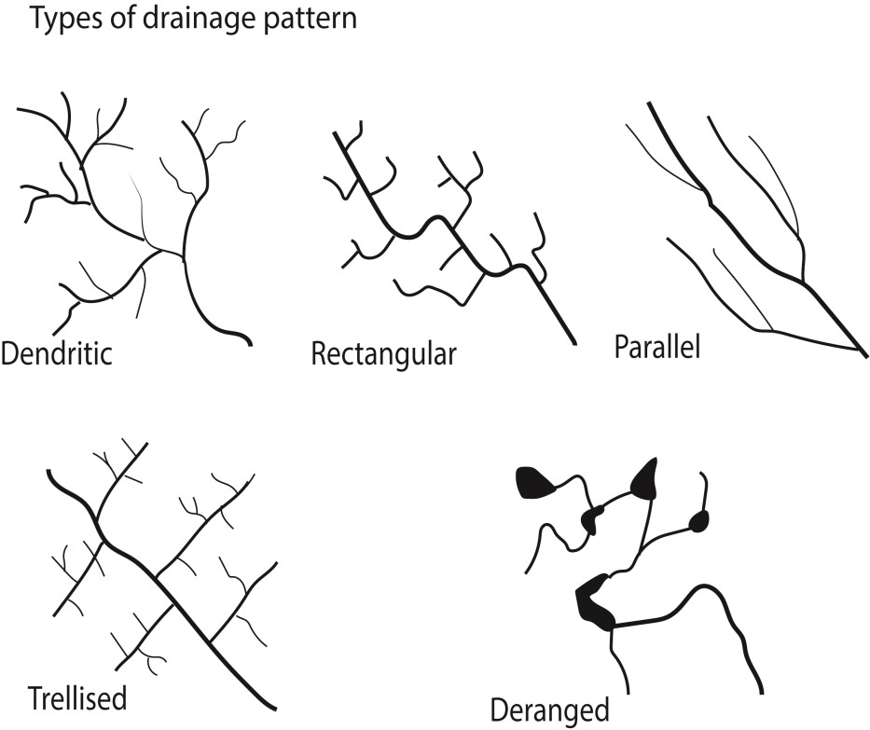

**The relationship between rock hardness and types of slope formation in East Africa**

* + Hard rocks are more resistant to erosion than soft rocks; hence rocks like quartzite, granites and gabbro often form upland *areas* with convex or waxing slopes on top.
  + Below the· waxing slope is the free face which is very steep sloping. This is due to erosion and weathering on a hard rock and mass wasting.
  + Down the free face is the constant or straight/ even slope that is gently sloping resulting from uniform weathering/erosion of hard or soft rocks and deposition from the free face.
  + Soft rocks **clay** and shales form lowlands that are deeply weathered or eroded to form concave slopes or waning slopes.,. Such slopes may also result from deposition.

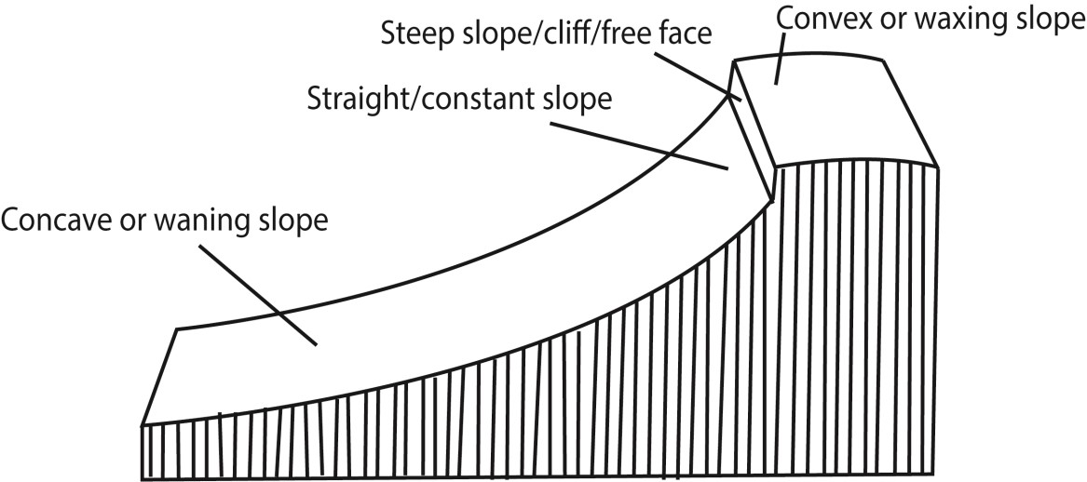

# Revision questions

1. Account for the formation of the major rock types in East Africa

(Candidates should define a rock, identify types of rocks depending on the mode of formation, then describe the different rocks- process of formation, characteristics, where they can be found in East Africa and importance)

1. (a) Examine the influence of igneous rocks on landform development in East Africa

(Define and describe igneous rocks. Explain origin and process of formation of igneous rocks, types of igneous rocks; describe extrusive and intrusive land forms formed from igneous rocks and identify areas in East Africa these are found)

(b) Assess the role of igneous rocks in the economic development in East Africa

(Give positive and negative importance of igneous rocks in East Africa) 3. (a) distinguish between metamorphic and igneous rocks.

(Describe the nature, process of formation and give examples of each)

(b) Examine importance of rocks in East Africa

(describe importance of rocks identifying areas in which they occur in East Africa)

1. (a) Account for the formation of sedimentary rock.

(Define, describe characteristics and conditions for formation of sedimentary rocks.) (b) Of what importance are sedimentary rocks.

(Describe positive and negative importance of sedimentary rocks in East Africa)

1. (a) What are metamorphic rocks

(Define, describe characteristics and conditions for formation of sedimentary rocks.)

* 1. Assess the importance of metamorphic rock I economic development of East Africa

(Describe positive and negative importance of metamorphic rocks in East Africa)

1. How is the nature of rock structure influenced the development of landform feature in East

Africa

(Define rock structure, identify and describe land forms formed by rocks in East Africa)

1. (a) Distinguish between extrusive and intrusive igneous rocks

(Giving examples define and explain the formation of each)

* 1. Describe land forms formed from extrusive igneous rocks

Thank you

Dr. Bbosa Science